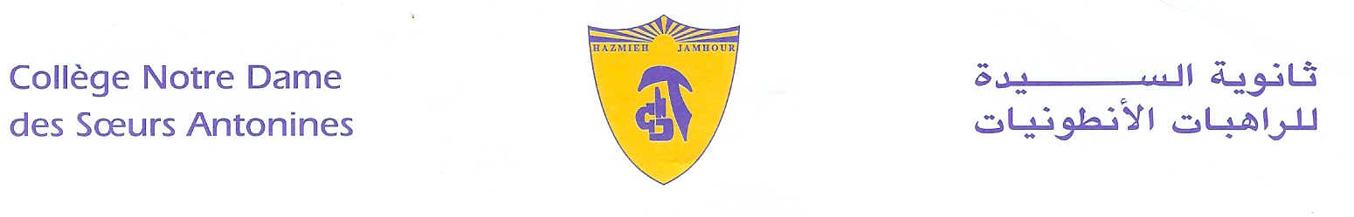
Book List
2019-2020
Grade1
- Reading- Journeys book- Gr1-Level 1.4-1.6- Houghton Mifflin- Harcourt.
- Wonders- Grammar practice Reproducibles.
- Spelling Connections -2- Zaner- Bloser-2016.
- Mathematics- Macmillan- Pupil’s book- 1A- 1B
- Science- Macmillan- Pupil’s book-1 + workbook-1- + CD (David and Penny Glover)
- Coccinelle- Méthode de lecture- CP- Hatier + Cahier d’Activités (1) et (2)- Programmes 2016.
- Vivre le francais, cahier d’écriture – EB1- Hachette- Antoine.
- Right Click Grade 1 – 2016 – Linfopourtous.
- ProtectEd- Student workbook- Level 1.

- لغتي فرحي- في القراءة- السنة الأولى الأساسية- سمر القاضي- دار الفكر اللبناني.
- البشرى السارة: الرب يسوع نور حياتي- السنة الأولى الأساسية- منشورات حبّة الحنطة.
Remark:
We would like you to pay at the Antonine Sisters School-Jamhour the fees for stationary and for cultural activities (obligatory, cf.Cir053/19), and buy the school uniform starting from Monday 9 till Friday 13 September 2019 from 8:30 a.m. till 13:30 p.m.
English, Math and science Books are available at school

Hazmieh, Place Mar Tacla - Tel +961 5 45 32 33 / 45 32 34 - Cell +961 3 60 04 37 - Fax +961 5 45 77 99
Jamhour, Rue EDL - Tel +961 5 76 90 27 / 76 90 28 - Cell +961 3 69 86 08 - Fax +961 5 76 84 15
B.P. 45 201 Hazmieh, Liban - www.antonines-hazmieh.edu.lb - info@antonines-hazmieh.edu.lb

